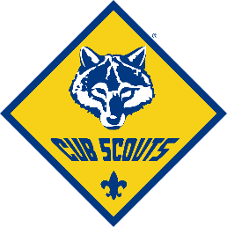**Tewksbury Pack 49**

**Code of Conduct**

**2024 – 2025**

The Cub Scout program is designed to be safe & fun. Adherence to this Code of Conduct by Cub Scouts, Parents, Leaders & Family Members will go a long way to keep the program safe and fun. The Scout Oath and Scout Law set out an appropriate “Code of Conduct” to be observed by all participants, at Pack & Den meetings and activities.

**The Scout Oath**

“On my honor I will do my best

to do my duty to God and my country

and to obey the Scout Law;

to help other people at all times;

to keep myself physically strong,

mentally awake, and morally straight.”

**The Scout Law**

“A Scout is trustworthy,

loyal, helpful, friendly,

courteous, kind, obedient,

cheerful, thrifty, brave,

clean, and reverent.”

In addition to following the Scout Oath and Scout Law – we require all Scouts and their families to adhere to the following Code of Conduct for all Den Meetings and Scout Activities:

**Expectations for Scouts:**

* Always be on time. Bear Den meetings will start promptly at 6:30 pm, unless otherwise specified. Notify your Den Leader if you will be unable to attend a Den or Pack activity.
* Wear the proper uniform with PRIDE - clean, neat, and complete - to all Scouting events.
* Listen and pay attention. In response to the "wolf ears" signal, silently return the sign; always follow Akela.
* Respect one another and your leader; keep hands and feet to yourselves; don't take anything from anyone else without first asking permission.
* Show respect for your surroundings, indoors and out – remember “Leave No Trace”

**Expectations for Parents, Guardians, and Family Members:**

* Please help your Scout learn and follow the Pack 49 Code of Conduct. Act as role models by demonstrating proper behaviors, language, etc.
* Work with the Adult Leaders to ensure all Scouts follow the Code of Conduct. Parents may be asked to remove disruptive children from Meetings or Activities. Parents should remember that they are also responsible for the conduct of their non-scout children during scouting activities.
* During scouting events, please make an effort to participate in the program, and in response to the "wolf ears" signal, silently return the sign along with the Scouts.
* Cub Scouting is a program based on parent or guardian and Scout participation. It is the policy of Pack 49 that a parent or guardian accompanies the Scout on all Pack activities, including Pack Meetings. Parents are encouraged to participate in Den level activities, but do not necessarily need to attend every Den Meeting. Please seek permission from your Den Leader or the Cubmaster for any “drop-off” scenarios.
* The use of drugs, alcohol, or tobacco products is forbidden at BSA functions.

**Action Plan to ensure compliance with Den Code of Conduct**

* All Scouts have the right to utilize the “Quiet Corner” when needed to calm themselves down or help them refocus. If asked to move to the quiet corner by an Adult Leader, Scouts should do so in a cooperative and respectful manner.
* If a Scout’s behavior becomes disruptive to the meeting, the Scout will be asked to sit outside of the meeting room with a Parent or Guardian until they are able to return and participate without being disruptive.
* Aggressive behavior will not be tolerated under any circumstances. Any Scout who becomes aggressive, will be asked to leave and not return to the meeting or activity. Examples of aggressive behavior include (but are not limited to): hitting, kicking, pushing or shoving, throwing things or knocking things over, or any other physical behavior towards another person. Aggressive behavior at any meeting or activity could also result in suspension from future meetings or activities at the discretion of the Den Leader and Pack Leadership.
* A Scout who continually has trouble following this Code of Conduct or is continually disruptive or aggressive at meetings or activities will be asked to meet with the Den Leader, the Cubmaster, and their Parent(s) or Guardian(s) to discuss the situation and review the Code of Conduct together. Continued non-compliance of the Code of Conduct by any Scout or their Parent or Guardian may result in removal from the Pack.

**Acknowledgement and Receipt**

I have reviewed the Pack 49 Bear Den Code of Conduct and agree to abide by the requirements set forth. I agree to review the Code of Conduct with my Scout, and will help my Scout follow the guidelines as outlined in this Code of Conduct. I will cooperate with and support the Adult Leaders as they work with all Scouts to ensure that all Scouts have a safe and fun environment to learn and grow. I will address any questions to the Den Leader, Pack Committee, or Cubmaster.

_________________________________________________________________________

Parent Signature Date

NAME(S) OF CUB SCOUT(S) _________________________________________________

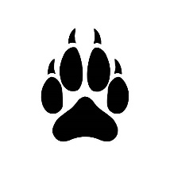**Bear Den Scout’s Promise**



* As a Bear Cub I will do my best to follow the Scout Oath and Scout Law at all times.
* I promise to follow the 3 Rs:



* + 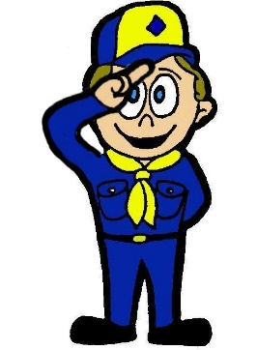Respect for others
  + Responsibility for myself and my things
  + Reasonable behavior
* I will follow the Bear Den Code of Conduct.
* I will listen and be respectful of my fellow Scouts and our Adult Leaders.
* 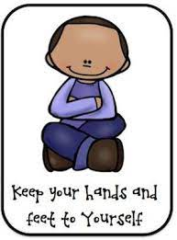I will keep my hands and feet to myself.

________________________________________________________________________

Scout Signature Date